Podiatry Registrant Data: December 2012

Published January 2013

Introduction
The functions of the Podiatry Board of Australia include:
- registering podiatrists, podiatric surgeons and students
- developing standards, codes and guidelines for the podiatry profession
- handling notifications, complaints, investigations and disciplinary hearings
- assessing overseas trained practitioners who wish to practise in Australia
- approving accreditation standards and accredited courses of study.

The Board’s functions are supported by Australian Health Practitioner Regulation Agency (AHPRA). For information about legislation governing our operations see AHPRA's Legislation & Publications at http://www.ahpra.gov.au/Legislation-and-Publications.aspx

The Board has analysed its registration data and produced a number of statistical breakdowns about registrants to share with the profession and community. The Board shares these breakdowns regularly.

For more information on podiatry registration, please see the Board’s website:
http://www.podiatryboard.gov.au/Registration-Endorsement.aspx

Index of Tables
Podiatrists: State and territory by registration type 2
Podiatrists: Age by registration type 3
Podiatrists: Gender by state and territory by registration rype 4
Podiatrists: Endorsement type by state and territory 4

Please Note: The numbers in this report reflect the National Board’s registration data as at 31 December 2012. These statistics include approximately 73 registrants who did not renew their registration by the end of the registration renewal late period for this profession, and were removed from the register on 3 January 2013, as required by the National Law.

Podiatrists: State and territory by registration type
State | General | General and Specialist | Non-practising | Total | % By State
ACT | 45 |  | 1 | 46 | 1.2%
NSW | 952 | 4 | 9 | 965 | 25.23%
NT | 14 |  |  | 14 | 0.37%
QLD | 649 | 1 | 10 | 660 | 17.25%
SA | 362 | 5 | 8 | 375 | 9.8%
TAS | 91 |  | 1 | 92 | 2.41%
VIC | 1,192 | 3 | 41 | 1,236 | 32.31%
WA | 390 | 11 | 5 | 406 | 10.61%
Not Stated | 24 | 1 | 6 | 31 | 0.81%
Total | 3,719 | 25 | 81 | 3,825

% State and territory
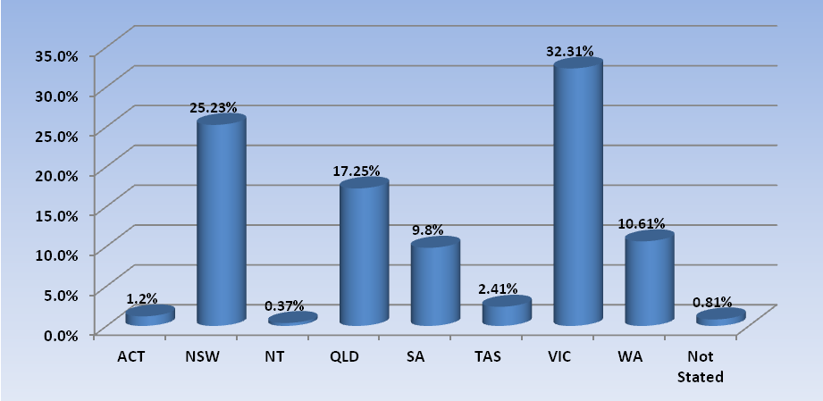

Podiatrists: Age by registration type
Age Group | General | General and Specialist | Non-practising | Total | % By Age Group
21 - 25 | 417 |  |  | 417 | 10.9%
26 - 30 | 747 |  | 19 | 766 | 20.03%
31 - 35 | 576 |  | 17 | 593 | 15.5%
36 - 40 | 545 | 6 | 6 | 557 | 14.56%
41 - 45 | 473 | 5 | 14 | 492 | 12.86%
46 - 50 | 360 | 4 | 9 | 373 | 9.75%
51 - 55 | 287 | 6 | 6 | 299 | 7.82%
56 - 60 | 162 | 2 | 1 | 165 | 4.31%
61 - 65 | 74 | 1 | 2 | 77 | 2.01%
66 - 70 | 40 |  | 5 | 45 | 1.18%
71 - 75 | 15 |  | 1 | 16 | 0.42%
76 - 80 | 5 |  |  | 5 | 0.13%
81 - 85 | 8 | 1 |  | 9 | 0.24%
86 + | 3 |  | 1 | 4 | 0.1%
Not Stated | 7 |  |  | 7 | 0.18%
Total | 3,719 | 25 | 81 | 3,825

% By age group
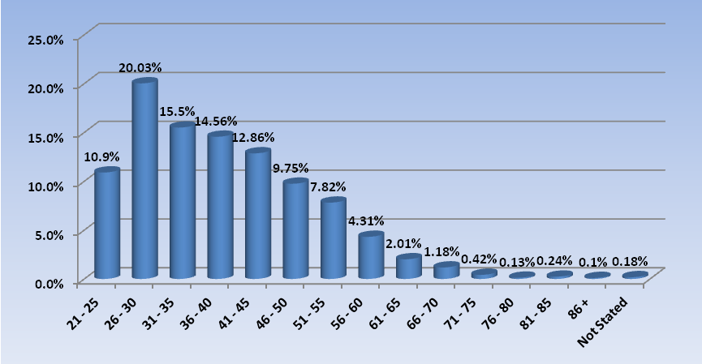

Podiatrists: Gender by state and territory by registration type
Sex | State | General | General and Specialist | Non-practising | Total Count | % By Sex By State
Female | ACT | 24 |  | 1 | 25 | 0.65%
Female | NSW | 542 | 1 | 4 | 547 | 14.3%
Female | NT | 6 |  |  | 6 | 0.16%
Female | QLD | 377 |  | 7 | 384 | 10.04%
Female | SA | 216 | 1 | 6 | 223 | 5.83%
Female | TAS | 21 |  | 1 | 22 | 0.58%
Female | VIC | 279 |  | 17 | 296 | 7.74%
Female | WA | 239 | 3 | 5 | 247 | 6.46%
Female | Not Stated | 10 |  | 2 | 12 | 0.31%
Female | Sub total | 1,714 | 5 | 43 | 1,762 | 46.07%
Male | ACT | 20 |  |  | 20 | 0.52%
Male | NSW | 394 | 3 | 5 | 402 | 10.51%
Male | NT | 6 |  |  | 6 | 0.16%
Male | QLD | 259 | 1 | 2 | 262 | 6.85%
Male | SA | 137 | 4 | 2 | 143 | 3.74%
Male | TAS | 14 |  |  | 14 | 0.37%
Male | VIC | 186 | 1 | 5 | 192 | 5.02%
Male | WA | 147 | 8 |  | 155 | 4.05%
Male | Not Stated | 11 | 1 | 1 | 13 | 0.34%
Male | Sub total | 1,174 | 18 | 15 | 1,207 | 31.56%
Not Stated | ACT | 1 |  |  | 1 | 0.03%
Not Stated | NSW | 16 |  |  | 16 | 0.42%
Not Stated | NT | 2 |  |  | 2 | 0.05%
Not Stated | QLD | 13 |  | 1 | 14 | 0.37%
Not Stated | SA | 9 |  |  | 9 | 0.24%
Not Stated | TAS | 56 |  |  | 56 | 1.46%
Not Stated | VIC | 727 | 2 | 19 | 748 | 19.56%
Not Stated | WA | 4 |  |  | 4 | 0.1%
Not Stated | Not Stated | 3 |  | 3 | 6 | 0.16%
Not Stated | Sub total | 831 | 2 | 23 | 856 | 22.38%
Total |  | 3,719 | 25 | 81 | 3,825

Podiatrists: Endorsement type by state and territory
Endorsement | NSW | QLD | SA | VIC | WA | Total
Scheduled Medicines | 2 | 2 | 4 | 15 | 25 | 48
Total | 2 | 2 | 4 | 15 | 25 | 48

