Podiatry Registrant Data: March 2013

Published April 2013

Introduction
The functions of the Podiatry Board of Australia include:
- registering podiatrists, podiatric surgeons and students
- developing standards, codes and guidelines for the podiatry profession
- handling notifications, complaints, investigations and disciplinary hearings
- assessing overseas trained practitioners who wish to practise in Australia
- approving accreditation standards and accredited courses of study.

The Board’s functions are supported by Australian Health Practitioner Regulation Agency (AHPRA). For information about legislation governing our operations see AHPRA's Legislation & Publications at http://www.ahpra.gov.au/Legislation-and-Publications.aspx

The Board has analysed its registration data and produced a number of statistical breakdowns about registrants to share with the profession and community. The Board shares these breakdowns regularly.

For more information on podiatry registration, please see the Board’s website:
http://www.podiatryboard.gov.au/Registration-Endorsement.aspx

Index of Tables
Podiatrists: State and territory by registration type 2
Podiatrists: Age by registration type 3
Podiatrists: Gender by state and territory by registration rype 4
Podiatrists: Endorsement type by state and territory 4

Podiatrists: State and territory by registration type

State | General | General and Specialist | Non-practising | Total | % By State
ACT | 45 |  |  | 45 | 1.17%
NSW | 978 | 5 | 9 | 992 | 25.75%
NT | 14 |  |  | 14 | 0.36%
QLD | 634 | 1 | 14 | 649 | 16.85%
SA | 369 | 5 | 7 | 381 | 9.89%
TAS | 91 |  | 1 | 92 | 2.39%
VIC | 1,199 | 3 | 36 | 1,238 | 32.14%
WA | 391 | 11 | 7 | 409 | 10.62%
Not Stated | 25 | 1 | 6 | 32 | 0.83%
Total | 3,746 | 26 | 80 | 3,852

% State and territory
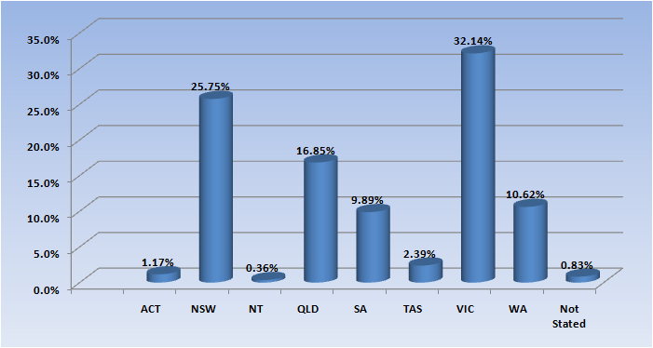

Podiatrists: Age by registration type
Age Group | General | General and Specialist | Non-practising | Total | % By Age Group
21 - 25 | 466 |  | 1 | 467 | 12.12%
26 - 30 | 750 |  | 20 | 770 | 19.99%
31 - 35 | 576 |  | 16 | 592 | 15.37%
36 - 40 | 550 | 7 | 7 | 564 | 14.64%
41 - 45 | 470 | 5 | 14 | 489 | 12.69%
46 - 50 | 358 | 4 | 8 | 370 | 9.61%
51 - 55 | 286 | 6 | 6 | 298 | 7.74%
56 - 60 | 156 | 2 | 2 | 160 | 4.15%
61 - 65 | 68 | 1 | 1 | 70 | 1.82%
66 - 70 | 35 |  | 4 | 39 | 1.01%
71 - 75 | 14 |  | 1 | 15 | 0.39%
76 - 80 | 3 |  |  | 3 | 0.08%
81 - 85 | 6 | 1 |  | 7 | 0.18%
86 + | 2 |  |  | 2 | 0.05%
Not Stated | 6 |  |  | 6 | 0.16%
Total | 3,746 | 26 | 80 | 3,852

% By age group
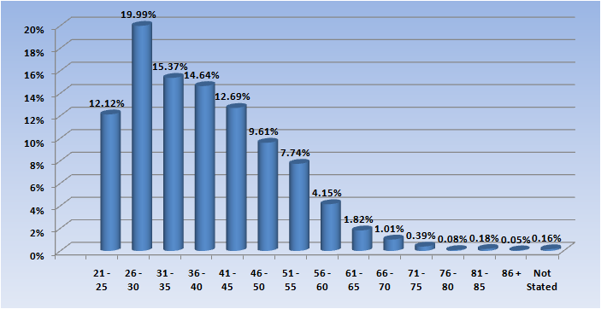

Podiatrists: Gender by state and territory by registration type
Sex | State | General | General and Specialist | Non-practising | Total Count | % By Sex By State
Female | ACT | 23 |  |  | 23 | 0.6%
Female | NSW | 558 | 1 | 4 | 563 | 14.62%
Female | NT | 6 |  |  | 6 | 0.16%
Female | QLD | 369 |  | 10 | 379 | 9.84%
Female | SA | 222 | 1 | 5 | 228 | 5.92%
Female | TAS | 21 |  | 1 | 22 | 0.57%
Female | VIC | 294 |  | 13 | 307 | 7.97%
Female | WA | 241 | 3 | 7 | 251 | 6.52%
Female | Not Stated | 11 |  | 2 | 13 | 0.34%
Female | Sub total | 1,745 | 5 | 42 | 1,792 | 46.52%
Male | ACT | 21 |  |  | 21 | 0.55%
Male | NSW | 405 | 4 | 5 | 414 | 10.75%
Male | NT | 6 |  |  | 6 | 0.16%
Male | QLD | 252 | 1 | 3 | 256 | 6.65%
Male | SA | 138 | 4 | 2 | 144 | 3.74%
Male | TAS | 15 |  |  | 15 | 0.39%
Male | VIC | 195 | 1 | 4 | 200 | 5.19%
Male | WA | 146 | 8 |  | 154 | 4.0%
Male | Not Stated | 11 | 1 | 2 | 14 | 0.36%
Male | Sub total | 1,189 | 19 | 16 | 1,224 | 31.78%
Not Stated | ACT | 1 |  |  | 1 | 0.03%
Not Stated | NSW | 15 |  |  | 15 | 0.39%
Not Stated | NT | 2 |  |  | 2 | 0.05%
Not Stated | QLD | 13 |  | 1 | 14 | 0.36%
Not Stated | SA | 9 |  |  | 9 | 0.23%
Not Stated | TAS | 55 |  |  | 55 | 1.43%
Not Stated | VIC | 710 | 2 | 19 | 731 | 18.98%
Not Stated | WA | 4 |  |  | 4 | 0.1%
Not Stated | Not Stated | 3 |  | 2 | 5 | 0.13%
Not Stated | Sub total | 812 | 2 | 22 | 836 | 21.7%
Total |  | 3,746 | 26 | 80 | 3,852

Podiatrists: Endorsement type by state and territory
Endorsement | NSW | QLD | SA | VIC | WA | Total
Scheduled Medicines | 2 | 1 | 5 | 17 | 25 | 50
Total | 2 | 1 | 5 | 17 | 25 | 50

